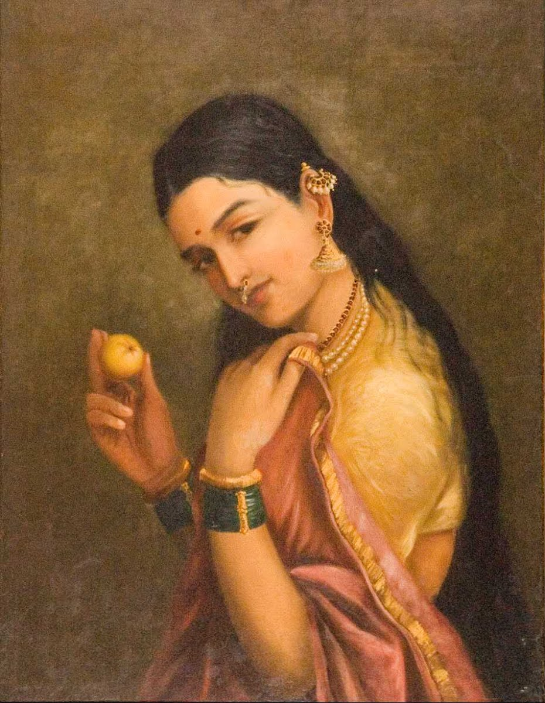

**Woman Holding a Fruit**

*Raja Ravi Varma, Late 19th century*

On discussion with Vani Ma’am, I picked this particular work from Raja Ravi Varma because I found it interesting how I can’t seem to visualise the intent behind the painting – it’s a portrait, but the woman has no name, nor is she extraordinarily beautiful. It feels like a regular girl, just being captured in time. Moreover, the pose and the fruit exude this sort of mystery and depth, as if there’s something it’s trying to say which I haven’t quite caught on.

**Rule of Thirds**

original artwork edited to comply with rule

The painting, much like most portraits, seems exempt from the *rule of thirds*, as our mind visually expects a portrait to frame the person in the centre. However, on applying the rule of thirds, the image seems to put on a rather modern, social-media-esque framing, almost looking like a 21th century girl with merely a unique filter to make it appear photographed instead of drawn. That’s probably only because of the associations of the rule of thirds with modern photography, but it’s still an interesting observation.

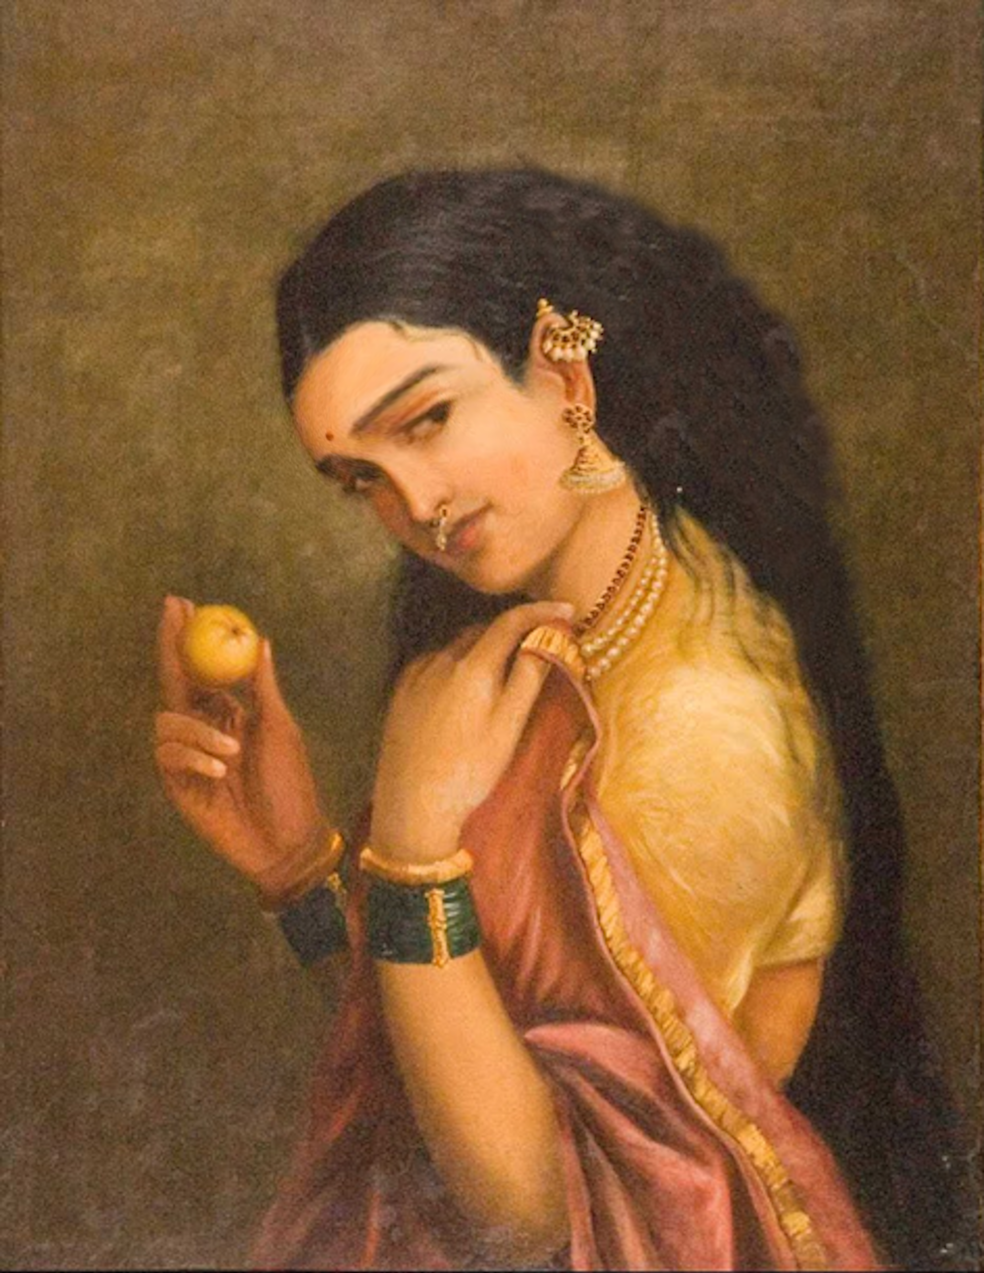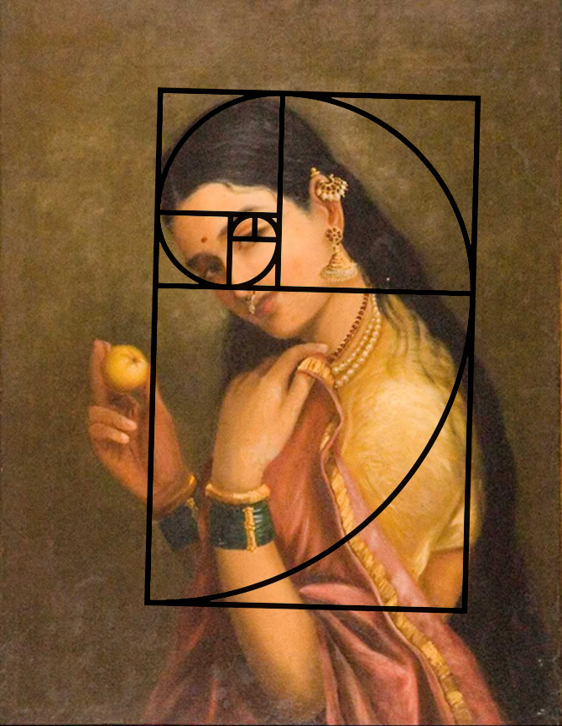**Golden Ratio**

original artwork edited to comply with rule

The painting vaguely remains consistent with Fibonacci’s golden ratio, though I’d chalk it closer to a coincidence than an intentional decision. Interestingly, the framing of the woman remains in the rectangle drawn by the ratio, while the fruit remains cautiously outside, which creates an intentional divide and distance between the two elements.

On poorly photoshopping the image to better comply with the rule (by giving her bigger hair and a heavier forehead), it feels less natural, and more Greek to me, for some reason.

**Detail and Colour**

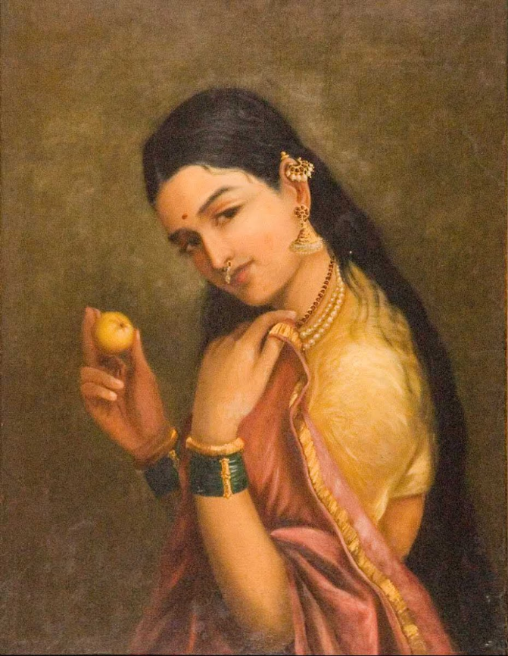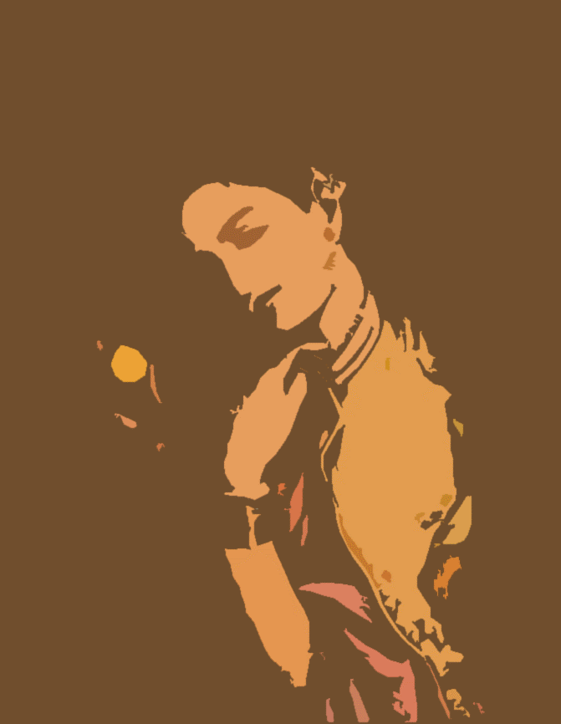

A little editing reveals that the detail in this picture centres around the face, the sari, and the fruit. Combined, these three elements seem to take up about 30-35% of the canvas, which fits the policy of higher detail to smaller elements and lower detail to larger elements.

However, another interesting detail is how the painting follows an almost constrained colour palate, with the only place where it differs is the bangles. The hair is the only darker element, with everything else being about the same level of luminance.